* **CSCI526-Final Project-Data Base Management System**
* **STUDENT RECORDS MANAGEMENT SYSTEM**
* **Team Members:**
* Srikantam Jayanth(50298996)

**TABLE OF CONTENTS**

**1. INTRODUCTION**

1.1 System building blocks

1.2 Registration Entity

1.3 Finance Entity

1.4 Health Entity

1.5 Game/Sport Entity

1.6 Cafeteria Entity

1.7 Accommodation Entity

1.8 Academia Entity

**2. ENTITY RELATION-SHIP (E-R)DIAGRAM**

2.1 The Data Dimensional Model

2.2 Network and Infrastructure and security

2.3 Quality plan

2.3.1 Examination plan

2.3.2 Cadent Plan

2.3.3 Defect Prevention (DP)

2.4 Planning

**3. DATA FLOW DIAGRAM (DFD)**

3.1 Students Registrations DFD

3.2 Students Records DFD

3.2.1 Level – 0DFD

3.2.2 Level – 1DFD

3.3 Logins DFD

3.3.1 Example of DFD and Use case diagram

**4. ACTIVITY DIAGRAMS**

4.1 Action States and Activity States

4.2 Transitions

4.3 Branching

4.4 Synchronization Bars

**5. CONCLUSION**

**Student Records Management System**

**Introduction:**

Maseno University is one of the public universities in Kenya that offers teaching and research services to its immediate customers, the students. The university has approximately over ten thousand students population distributed among the ten faculties that the institution had established. Each faculty has four to six departments within it and each department is able to offer two to three different degree programs to the students.

Within the college setup, students can have access to the library (where they can both study and borrow academic materials), various computer labs (for internet research related activities), the students canteen and cafeteria (for meals and fast foods), play grounds (for various sports games activities), different hostels (for accommodation purposes), the university’s hospital (for disease diagnosis and treatment), various lecture halls (for both lectures and examinations), among other facilities within the university premises.

Upon making an application with the university, the selection committee makes recommendations and issues admission numbers and letters to prospective students. The life of a student in the said university begins at this stage.

The university is interested in developing a student records management system that would be able to capture all these information in a distributed computing setup. This write-up, therefore, documents the various building perspectives and scenarios used in coming up with the system. The document shall discuss among many others, the database system and its various related components that would be deployed at the back end of the system.

**System Building Blocks:**

The system shall consist of different building blocks managed by different administrators. There will be student registration entity, finance entity, academia entity, health entity, accommodation, cafeteria entity and games/sports entity. All these entities will have the student as the primary focus of their operations.

***Registration Entity:***

This will form the primary entry point for any student into the university. Here, demographic and personal data along with the admission number will be collected. These will be unique identifiers for each student and have to be unique for everyone. A single admission number can only be used by a single student for eternity. Moreover, this entity will capture the next of kin related information. The next of kin can be contacted in case there is an emergency or discipline related scenario that requires his/her input.

Some of the attributes for this entity will include: First name, last name, ID/Passport number, Parents/guardian details, Email addresses, Student Admission number among others.

***Finance Entity:***

All the institutions finances are managed from this entity. When a student remits fee payment to the university’s fee account, the same is reflected on the university’s finance system. This entity captures the total fees that is supposed to be paid by the student, the program of study and semester. Moreover, the entity shows the actual outstanding fee balance that the student has.

For student’s records, all students’ data and fee collections including the deficits are captured in this entity. The finance entity will have attributes such as: Student admission number, program enrolled, academic year, semester, fee amount, paid, deficit, date of payment among other attributes.

***Health Entity:***

Health is a very sensitive entity not only to the students, but to the university management too. This system building block entity will have student health related information including existing medical history and the responsible physicians. The entity too shall incorporate the hospital admission numbers for either in-patient or out-patient depending on the health condition of the student at the point of hospital admission.

Some of the attributes associated with this entity include: Student admission number, in-patient/out-patient number, medical history, family doctor, program of study, parent/guardian details.

***Cafeteria Entity:***

There are students who would be interested in getting their meals from the institution’s cafeteria and therefore, related information including cafeteria fee has to be captured. The meals offered at the university’s students cafeteria is at a subsidized price that is relatively affordable by all. Moreover, the ingredients and food products being used are locally produced within the university. Under this entity therefore, the following attributes will be captured: Student admission number, cafeteria fee, semester, academic year among other attributes.

***Games/Sports Entity:***

The aim of the university is to develop an-all-round student who participates not only in curriculum activities, but on co-curriculum activities too. It is therefore, the expectation of the university that each student needs to be a member of at least one sporting activity. The university has both outdoor and indoor sporting activities that is open to all students within the university premise. A student only needs to choose on the sporting/game activities he/she is interested in and register with the relevant authorities. Some of the attributes that will be associated with this entity include: Student admission number, sporting activity/activities, year of study, academic year, and semester among other attributes.

***Accommodation Entity.***

The interest of the university is to host all the students that it admits into its programs. Students’ lives majorly rotates between academics section and accommodation premises. The university therefore, has various hostels that students can stay in for those students willing to be accommodated by the university. The university charges an extra accommodation fee that has to be paid per semester on to those students willing to be accorded aboard by the university. This entity shall have attributes such as: Student admission number, hostel name, year of study, academic year, semester, accommodation fee, paid/not-paid, and hostel admin among other attributes.

***Academia Entity***

This is the core function of the university and the student. A student’s life rotates around academic activities and related phenomenon. The academic entity can be divided into sub entities to include the learning period and the examinations.

Under learning and upon acceptance of semester admission, each student is expected to make a choice of the course units to do per semester after finalizing with the registration and admission entities. Depending on the units selected, the student is expected to attend to all the lectures in the respective allocated lecture halls and be signing the attendance register whenever he/she has attended lectures in respective lecture halls.

Some of the associated attributes to this sub entity include: Student registration number, program, course unit, lecturer, lecture hall, attendance, duration, day of the week, reviews among other related attributes.

In the examinations and results sub entity, each student will be expected to register for a course unit examination especially if the student has attended 70% of the lectures. Each examination paper will be assigned respective examination rooms, which doubles up as lecture rooms, and every student is entitled to an examination results provided he/she did the examinations.

Some of the attributes that are associated with this sub entity include: Student registration number, examination code, exam date, exam hall, exam time, semester, academic year, year of study, results and the results comments among other related attributes.

From the system entities discussed above, the key attribute identifier for all the entities is the Student admission number. Therefore, the Student admission number will be used as the primary key identifier while developing the database for this system.

**The Entity Relationship Diagram:**

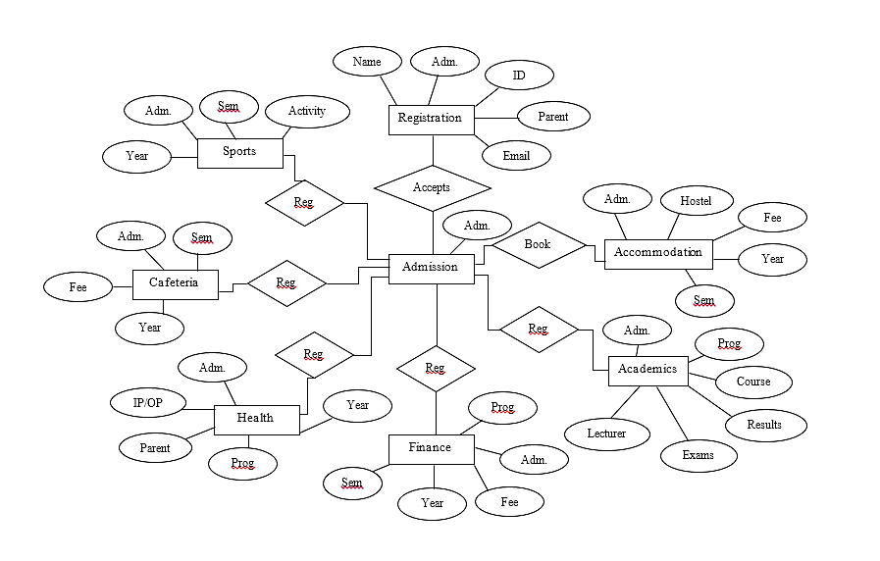

**The Data Dimensional Model:**

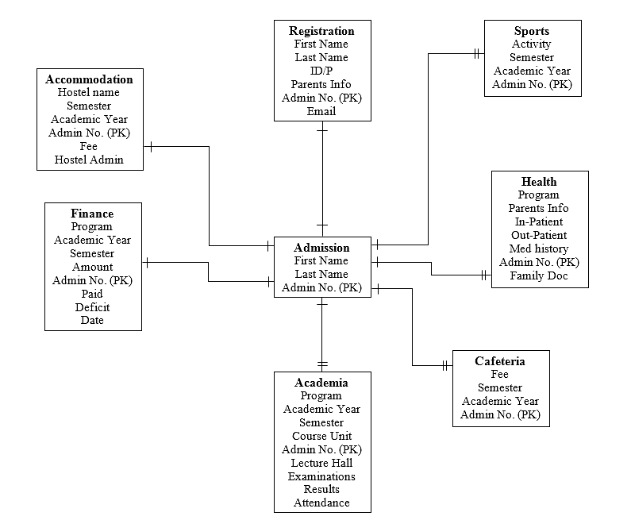

**Network Infrastructure and Security:**

The university has invested heavily on its network and security of the same network and data. The entire university runs on a fiber-optic cable backbone network infrastructure. The various labs and related offices that have desktop machines have Ethernet cables mounted onto the various routers and switches.

The university has further deployed various network Access Points (APs) within its premises. These APs are prioritized with the ones at the university’s administration given the highest priority, while those at the students’ cafeteria environment given the least priority. For one to gain access and use the APs services, authentication and authorization has to be effected. This helps in thinning out unwanted network users from the system.

The APs that can be accessed and used by the students are distributed all over the campus environment, in respective academic departments, facilities and other common joints that students share. All the APs requires user authentication and authorization credentials in order to gain entry.

The university has also invested heavily on quality human resource, network and database engineers. These individuals ensures that the university has an optimum and an ever present functioning network system. Equally, the university has on-site firewalls mounted within the server rooms that prohibits/limits/denies any unauthorized access into the system. This has helped to secure the various application systems that are run by the university from the servers, student records system is one of the systems installed within the university’s server.

To better secure their network infrastructure and the related applications, the university has set up an automatic password updater that refreshes the servers fortnightly. The Chief Technical Officer is the only individual allowed to have an access to this password.

The various high sensitive data rooms have both their doors and windows burglar proofed and various security authentication and authorization frameworks are put into place to safeguard the already established data.

**Quality Plan**

**Examination Plan:**

The proposed students’ records management system project will be audited periodically based on the aspects as listed in the table below.

| **Audit Type** | **When / frequency** | **Audit by** | **Applicability** |
| --- | --- | --- | --- |
| Start Audit | Project beginning | SQA | ALL types of projects |
| Work product audit | Before each deliverable(in case of Development/Large Maintenance Work) | QL | Not applicable to Application support/Infrastructure management Service/ERP Production Support: |
| Process audit | Once in a month | QL | ALL types of projects |
| Closure audit | After project completion/ once in six months (in case of long maintenance/support projects) | SQA | ALL types of projects |
| Configuration audit | Once in a month | CL/QL | Combined with Process audit |
| Additional audit (Audits executed/expected by Client as per contract) | Event Based | External experts | Optional |

Audit observations and corresponding actions will be recorded in the Audit log.

**Cadent Plan:**

Cadent are used for analyzing, monitoring and controlling the performance of the project to ensure that the project objectives are met. The project cadent will be collected on a periodical basis and the areas of improvement/showstoppers will be identified and rectified instantly.

**Defect Prevention (DP):**

Defect prevention (DP) activity involves identifying, analyzing commonly caused defects in projects and taking actions well in advance to prevent them from occurring again. DP activity is carried-out throughout the project life cycle. Major defects identified for the project type are entered in the project DP Log. Trend analysis is carried out for the Design, Coding phases and in the project end. DP Plan will be reviewed by the DP member. As per the project plan the DP meeting will be conducted on the completion of every milestone. Causal analysis and resolution methodologies will be followed to analyze recurring defects and action plan will be implemented to minimize their recurrence.

**Planning:**

Major review activity for the entire project will be carried-out as per review procedure. The work product to be reviewed will undergo self-review process before peer reviews. Review findings will be recorded in Review Log/Defect Tracking System.

**Data Flow Diagram (DFD)**

***Student Registration DFD***

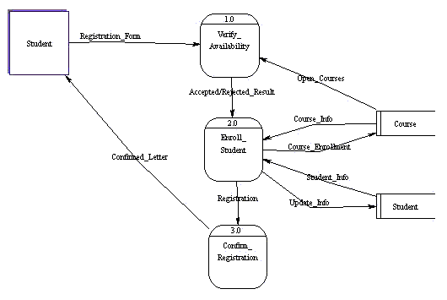

***Student Records DFD:***

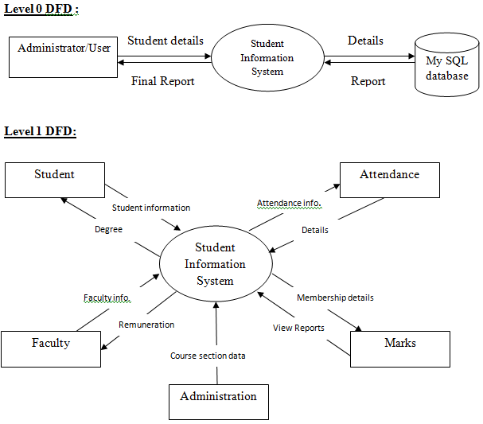

***The Logins DFD:***

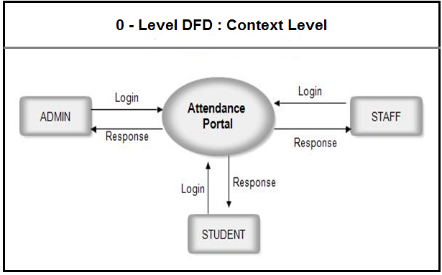

***An example of DFD and use case diagram for the Library Component:***

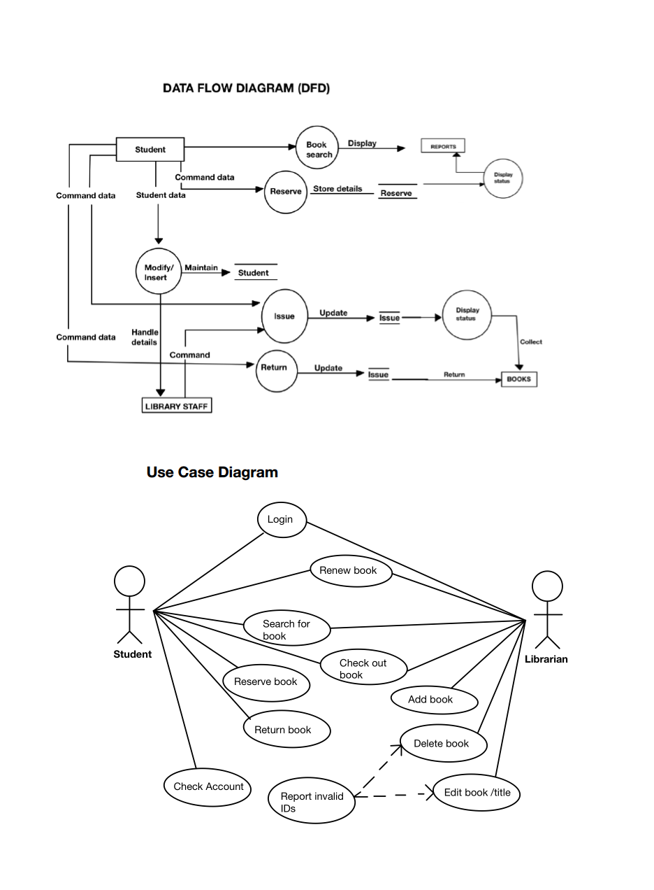

**Activity Diagram.**

An Activity diagram is a visual representation of any system's activities and flows of data or decisions between activities. Activity diagrams provide a very broad view of a business process. They represent the dynamics of a system. They are flow charts that are used to show the work flow of a system. They show the flow of control from activity to activity in the system. They show what activities can be done in parallel, and any alternative paths through the flow.

Purpose

* + Model business workflows
  + Model operations

Activity diagrams commonly contain

* + Activity states and action states
    - Transitions
      * Objects

**Action States and Activity States**

Action states are atomic and cannot be decomposed. Work of the action state is not interrupted. Activity states can be further decomposed. Their activity being represented by other activity diagrams. They may be interrupted. Represented in UML by a rounded rectangle.

*Activity* represents the performance of some behavior in the work flow.

**Transitions:**

Transitions are used to show the passing of the flow of control from activity to activity.

They are typically triggered by the completion of the behavior in the originating activity**.**

When the action or activity of a state completes, flow of control passes immediately to the next action or activity state**.**

A flow of control has to start and end at some place

Initial state -- a solid ball stop state -- a solid ball inside a circle

 

**Branching:**

When modeling the workflow of a system, it is often necessary to show where the flow of control branches based on a decision point.

The transition from a decision point contain a guard condition. The guard condition is used to determine which path from the decision point is taken. Decisions along with their guard conditions allow you to show alternative paths through a work flow**.** A branch specifies alternate paths taken based on some Boolean expression. A branch may have one incoming transition and two or more outgoing ones.

**Synchronization Bars:**

In a workflow there are typically some activities that may be done in parallel. A synchronization bar allows you to specify what activities may be done concurrently.

A synchronization bar may have

* + many incoming transition and one outgoing transition, or
  + one incoming transition and many outgoing transitions.

It is use to specify the forking and joining of parallel flows of control. A synchronization bar is rendered as a thick horizontal or vertical line.

A fork may have one incoming transitions and two or more outgoing transitions

* + each transition represents an independent flow of control
  + conceptually, the activities of each of outgoing transitions are concurrent
    - either truly concurrent (multiple nodes)
    - or sequential yet interleaved (one node)

A join may have two or more incoming transitions and one outgoing transition

* Above the join, the activities associated with each of these paths continues in parallel.
* At the join, the concurrent flows synchronize.

- Each waits until all incoming flows have reached the join, at which point one.

- Flow of control continues on below the join.

**CONCLUSION:**

**---------------------- IS LEFT OVER---------------------------------**